UniCampus

Project Description:
UniCampus is a unified, AI-powered web platform designed exclusively for college students. It centralises the fragmented tools and interactions that students rely on daily — resource sharing, team formation, event discovery, academic assistance, and campus commerce — into a single, verified, campus-specific ecosystem.

Problem Statement:
Students across college campuses face systemic challenges: study resources are scattered across WhatsApp groups with no structure; team formation relies entirely on personal networks leaving skilled but less-connected students at a disadvantage; campus events and internship opportunities are communicated through fragmented channels; academic doubt resolution depends on general-purpose AI lacking campus-specific context; and there is no verified, trusted layer connecting students within the same institution.

Proposed Solution:
A full-stack web platform combining a React + Vite frontend with a modular Node.js + Express backend, MongoDB Atlas for data storage, Cloudinary for media and PDF handling, custom email OTP + JWT authentication for verified student identity, and AI-assisted campus features — all deployed using Vercel (frontend) and Render (backend). The platform follows a loosely coupled modular monolith architecture to support scalable feature evolution and independent module development.

Technologies Used:
- React.js
- Vite
- Tailwind CSS
- React Query
- Node.js
- Express.js
- MongoDB Atlas
- JWT
- Cloudinary
- Resend (Email OTP Service)
- Claude API (Anthropic)
- Vercel
- Render

System Architecture:

Three-tier modular monolith architecture where a React SPA frontend hosted on Vercel communicates through a custom email OTP + JWT authentication layer with a Node.js + Express REST API hosted on Render. The backend follows a loosely coupled modular architecture and interfaces with MongoDB Atlas for data storage, Cloudinary for media and PDF storage, and AI service integrations for selected intelligent campus features.System

Architecture Diagrams:
Figure 1 — Request lifecycle: from browser through Vercel CDN, auth check, Node.js API, and back.

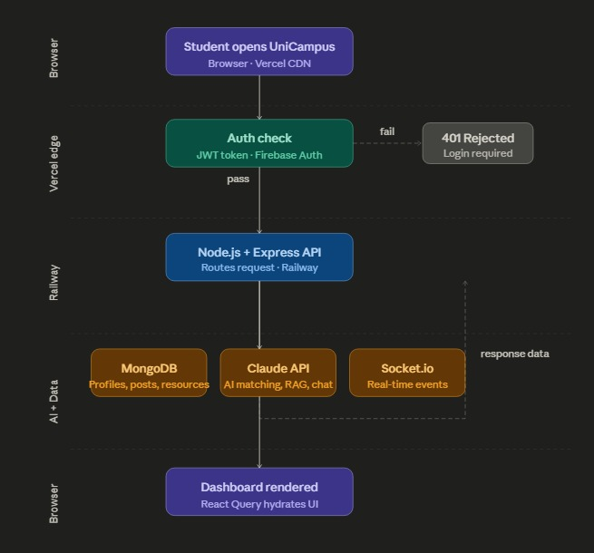

Figure 2 — Layered system architecture: Frontend (React SPA), Auth layer (Custom Email OTP + JWT / Firebase), Backend API (Node.js + Express), and AI + Data layer (MongoDB, Claude API, Socket.io, Cloudinary).

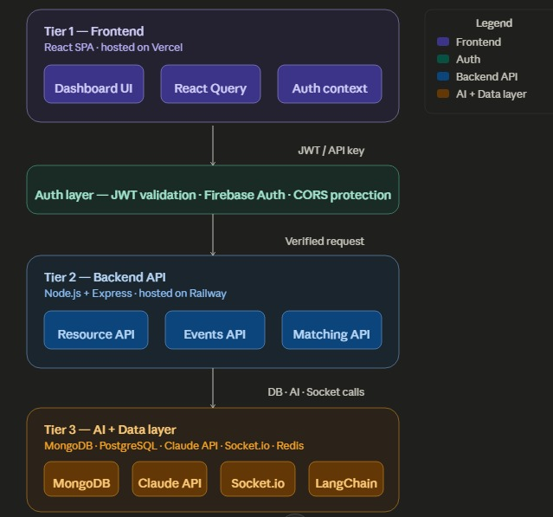

Functional Requirements:
College Identity Verification
- Students register using their institutional email address (e.g., .edu or college-specific domain)
- OTP-based verification sent to institutional email before account activation
- Fallback verification via student ID document upload with admin approval
- Verified badge displayed on all user profiles
- All trust-dependent features restricted to verified users only
- Periodic re-verification mechanism to deactivate graduated or inactive accounts
Resource Library
- Resources organised by department, academic year, semester, and subject
- Upload notes, previous year question papers, lab manuals, assignment solutions, and reference PDFs
- Upvote and quality-rating system to surface the most useful content
- Examination-period tagging for high-relevance resource marking
- Full-text search across all uploaded documents
- Duplicate detection to prevent redundant uploads across departments
- Download tracking for most-accessed materials each semester
- Structured resource categorisation and keyword-based search for uploaded academic materials

Campus Events Hub
- Clubs, departments, and student councils can post events with venue, time, and registration details
- RSVP functionality with attendee lists visible to organisers
- Social visibility showing which peers are attending
- Push and in-app reminder system: 24 hours and 1 hour before events
- Attendance QR code system for verified event check-in
- Team registration support for hackathons and coding competitions
- Event moderation layer to prevent spam listings

Smart Teammate Matching
- Detailed student profiles including skills, tools, academic year, department, and availability
- Project interest tags (web dev, ML, competitive programming, design, etc.)
- Urgent teammate request feature with immediate campus-wide visibility
- Mutual match confirmation system preventing unwanted contact
- Reliability score from project completion history, response rate, and peer ratings
- GitHub and portfolio integration for skill credibility
- Compatibility score visible on match suggestions with explanation
- Profile-based compatibility suggestions using shared skills, interests, department, and project preferences

Internship & Opportunity Board
- Opportunity categories: internships, job referrals, hackathons, competitions, research, club recruitments
- Senior students and alumni can post referral opportunities exclusively for their college network
- Skill-based filtering to surface relevant opportunities
- Application tracking to mark and monitor applied opportunities
- Referral request system to reach out to seniors at specific companies
- Deadline reminders for approaching application cut-off dates
- Opportunity verification layer against spam or scam postings
- Resume submission directly within the platform
- Skill-based opportunity filtering and profile-linked application tracking

Skill Portfolio & Verified Badges
- Students list technical skills, tools, and domains with GitHub links, project descriptions, and certificates
- Peer endorsement system for verified skill validation
- Event-linked badges auto-issued on verified attendance via Events Hub
- Hackathon and competition achievement records verified by event organisers
- Portfolio visibility settings for controlled sharing
- Manual and profile-linked skill tagging with portfolio integration

AI-Assisted Academic Doubt Support
- Scope restricted to uploaded curriculum documents, syllabi, and approved resources only
- Natural language doubt queries referencing specific subjects, topics, or PDF pages
- Subject and department-specific conversation scoping
- Doubt history saved per student for revision and follow-up

Study Groups & Collaborative Chat
- Course-linked group creation tied to specific subjects, semesters, and departments
- File sharing for notes, question papers, and reference materials within group threads
- Pinned resources section within each group
- Thread-based discussion organised by topic
- Group size limits based on enrolled course membership

Campus Marketplace
- Listings for second-hand textbooks, lab coats, electronics, hostel utilities, cycles, and event passes
- Seller and buyer profiles drawn from the verified campus identity system
- Smart filters: department-relevant items, hostel pickup, price range, urgency
- Seller rating and review system for transaction history and trust
- Direct in-app chat between buyer and seller
- Mark as Sold and delivery confirmation to close transactions cleanly
- Graduating senior listings category for batch-wide sales
- Verified student marketplace with moderation and reporting support

Personalised Content Feed
- Content categories: event announcements, new resource uploads, opportunity postings, project showcases, campus news
- Ranking algorithm based on recency, peer network activity, and relevance
- Trending on your campus section surfacing rapidly engaging content
- Department-specific and year-specific content filtering by default
- Spam filtering and duplicate detection to maintain feed quality
- Personalised content prioritisation based on department, semester, recency, and engagement

Non-Functional Requirements:
Performance
- Page load under 2 seconds on standard college network connections
- API response under 3 seconds for all standard operations
- Support 100+ concurrent users per campus instance

Security
- All traffic encrypted via HTTPS/TLS
- JWT tokens with expiry and refresh — credentials never stored in plain text
- OTP-based email verification and optional student ID document upload as fallback
- Content moderation via Claude API for marketplace listings and opportunity posts

Scalability & Availability
- 99.5% uptime target with Vercel (frontend) and RAG Render (backend) deployment
- MongoDB Atlas managed cloud database with auto-scaling

Accessibility & Code Quality
- Lighthouse accessibility score 90+ target
- Minimum 70% test coverage on critical backend routes
- Tailwind CSS utility-first styling for consistent, responsive UI

Technology Stack:
Confirmed Stack:

Category | Technology | Role / Purpose
Frontend | React.js + Vite | Component-based SPA with fast HMR and optimised builds
Styling | Tailwind CSS | Utility-first CSS framework for rapid, consistent UI
Backend | Node.js + Express.js | RESTful API server with scalable JavaScript runtime
Authentication | JWT + NodeMailer OTP | Stateless session tokens with Google SSO support
Primary Database | MongoDB Atlas | Flexible document store for profiles, posts, resources
File Storage | Cloudinary | Direct frontend uploads — backend stores URL strings only
Real-time Layer | Socket.io | WebSocket-based real-time chat and live notifications
AI Integration | Claude API (Anthropic) | AI chatbot, content moderation, and matching logic

Extended / Conditional Stack:
Category | Technology | Required If
File Storage | Cloudinary | Resource library with PDF/image upload is implemented
Deployment | Vercel and Render | Simplified cloud deployment over raw server management
RAG Framework | LangChain + PDF chunking | Syllabus-specific AI doubt solver with document retrieval

Scope:
In Scope
- College identity verification and OTP-based student onboarding
- Resource library with upload, search, upvote, and AI summarisation
- Smart teammate matching with AI-powered compatibility scoring
- Internship and opportunity board with AI skill-to-opportunity matching
- Skill portfolio, verified badges, peer endorsements
- AI-powered doubt solver chatbot using RAG + LangChain + Claude API
- Study groups with course-linked chat, file sharing, and AI summaries
- Campus marketplace with verified listings and in-app chat
- Personalised content feed with AI-powered interest ranking
Out of Scope
- Support for non-college or unverified users
- Mobile native applications (iOS / Android) — web only for this version
- Inter-college or cross-institution networking in the MVP
- Real-time video or audio calling features
- Payment gateway or financial transaction processing for the marketplace
- Enterprise SSO or LDAP integration

Future Enhancements:
- Karma / reputation system visible across all features to reward consistent contributors
- Analytics dashboard for club admins and department coordinators
- Alumni network integration for mentorship and long-term referral connections
- Multi-college federation: shared opportunity board visible across verified institutions
- Mobile-first PWA version after web MVP is stable and adopted
- AI resume builder aligned to specific opportunity requirements on the platform

Conclusion:
UniCampus is a well-scoped, technically grounded full-stack platform that directly addresses the most persistent pain points in college student life. Its key strength is the verified campus identity layer, which underpins trust across all features and differentiates it from generic tools like WhatsApp groups or open social platforms. The AI integrations — particularly the verified identity system, structured resource sharing, and modular campus collaboration features — are designed as utility-first features with measurable student value rather than decorative additions. The depth-first development strategy, beginning with the Resource Library and Events Hub to drive initial adoption, is sound: these features have the highest daily engagement potential and will bootstrap the content ecosystem that makes teammate matching and the opportunity board more effective over time. The primary growth challenges are achieving critical adoption density within the first campus cohort, sustaining the AI compute costs at scale, and evolving the marketplace and personalised feed once sufficient content density exists.

Project Type: Full-Stack Student Collaboration Platform — Web Development · Cloud Computing · Scalable Backend Systems

